**Video Resources:** [**Secrets Hidden in Images (Steganography) - Computerphile**](https://www.youtube.com/watch?v=TWEXCYQKyDc)

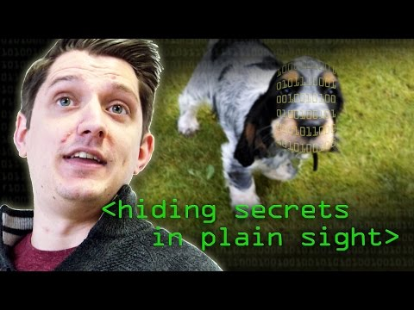

[**"Musical Steganography: Hiding Things in Music" by Scott Fradkin**](https://www.youtube.com/watch?v=gLXqZVHrFa4)

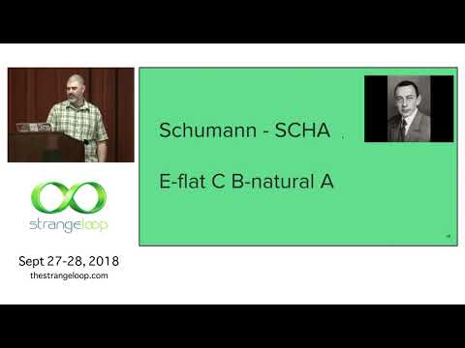

[**Hide Any File in an Image - Steganography Tutorial**](https://www.youtube.com/watch?v=l0-z-hKYT1Q)

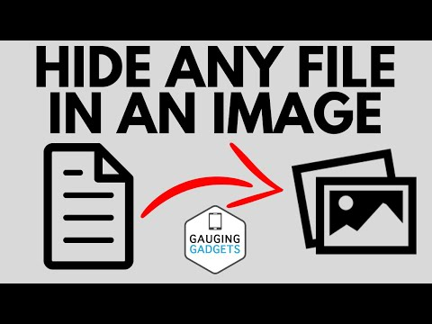

**Steganography:**

Steganography is a technique used in order to hide messages within another medium, this could be a picture, video, email, music and many other forms. In fact in ancient Greece messengers would have messages tattooed on their head and would wait for the hair to grow back. When they arrived at their destination their heads would be shaved and the messages revealed. This was obviously a very primitive method, and digital methods of today are much more advanced. The basic concept here is that a message is hidden by one party in a total normal looking form and can be uncovered by another via some obscure piece knowledge.

In the modern world messages can be hidden in various mediums using a whole bunch of techniques. One technique that can be used is manipulating the individual bits of a file in order to hide a message. This works because when you change only the least 2 bits of an 8 bit number with in a byte within a picture that is Megabytes in size the difference to the naked eye is indiscernible especially if you are only able to see the modified file. Other methods include modifying compression algorithms such as jpeg in order to create an even more random method of hiding. It is possible to discern that there may be a message hidden within your file by using some various statistical processing methods such as histograms and machine learning.

Some practical uses of steganography are water marks on digital media. These water marks can be applied to the media with no discernable changes to the original media, however, if the material is distributed illegally then it may be possible to identify the distributor based upon the unique water mark.

If you want to learn more about how the jpeg compression formula is specifically modified to hide a poem you can check out this link. <http://www.guillermito2.net/stegano/jsteg/index.html>

**Pictures:** There are three images with hidden messages, you can edit the images in anyway you need too in order to make the message more readable. The message is in plain text hidden somewhere within the image, no additional tools are required.

**Answers:**

Reactor picture (easy) – message: Hacker



PNNL Ariel View (medium) – message: Security

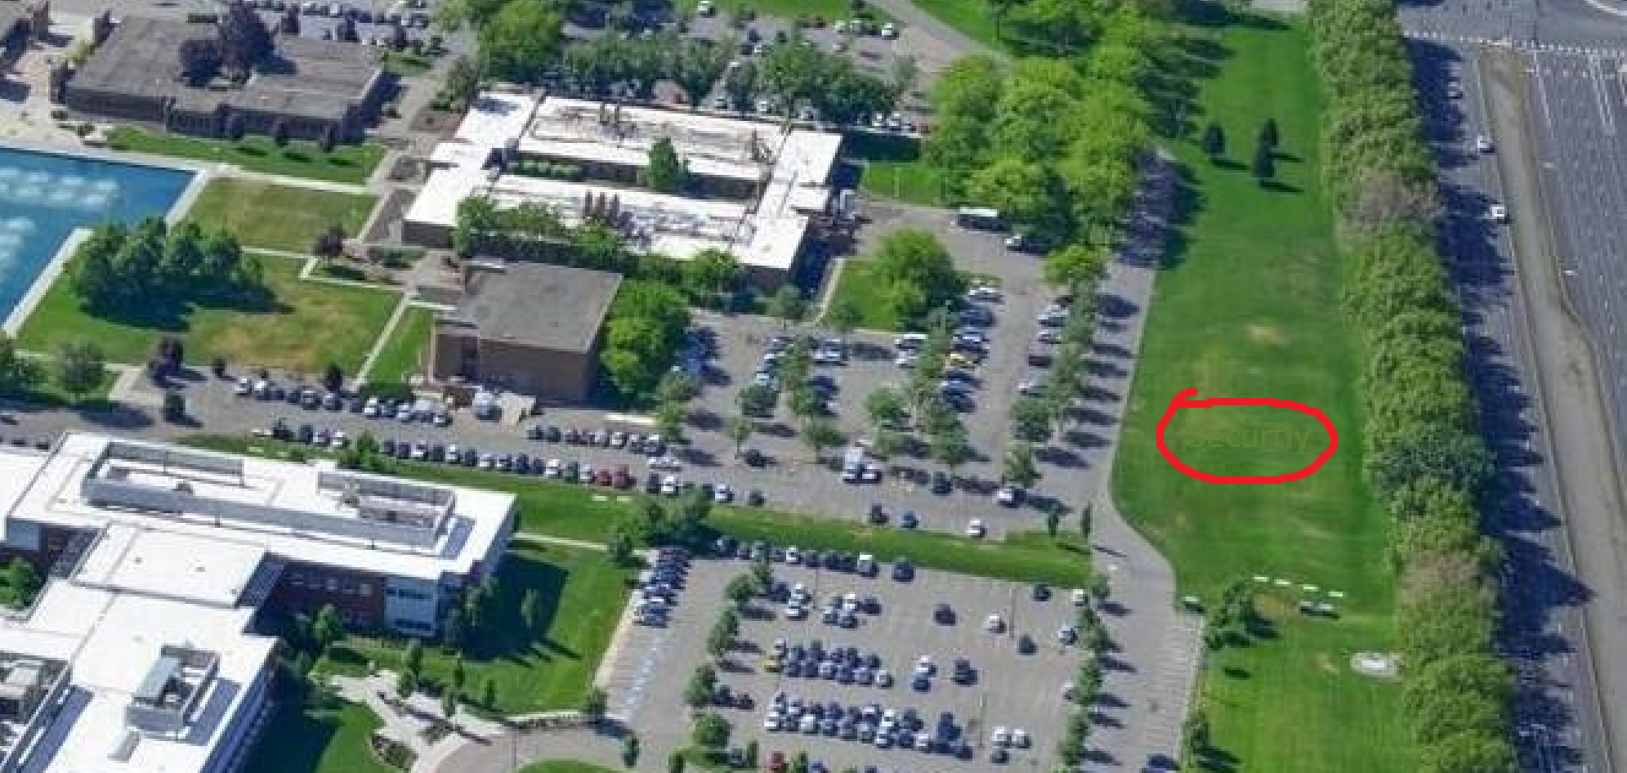

White House (good luck) – message: Energy

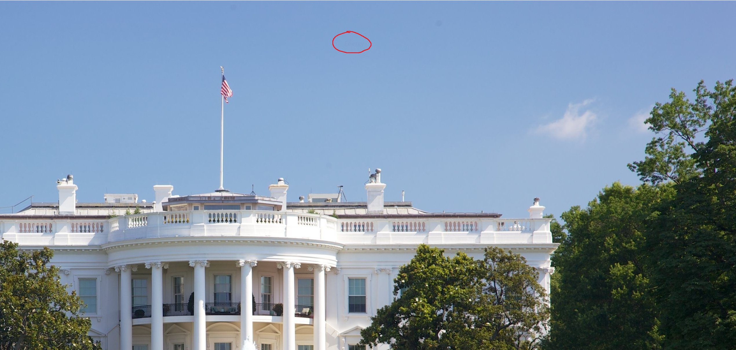

**Musical Message:** There is a short measure of sheet music encoding a message within the notes. Find the key that encodes this musical message. The notes currently encode the most popular English pangram. Use this information to deduce which note corresponds to which letter.

**Answer:** In order to solve this puzzle you would first google “the most popular English pangram” this would then lead you to the sentence. “The quick brown fox jumps over the lazy dog.” This is the message that is encoded by the notes in the steganography pdf. You would then use this to decode the musical notes and create a key. The key is shown below.

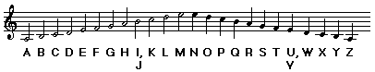

**Flag:** Beethovens fifth symphony

**Bonus (audio only):** Cloud